The event will take place on Sunday 15th May 2016 at Exe Valley Leisure Centre, Bolham Road, Tiverton, Devon, EX16 6SG. Registration opens on the day of the event from 7am and will remain open until all competitors have registered.

On arrival please go to the registration desk. This is located inside the main building, Turn left at reception then immediately right. Registration will be in the studio at the end of the short corridor. Here you will be issued with your race numbers and timing chip. You will receive a numbered label which must be fastened to your bike. This is for security reasons on exiting transition post race. If your bike number does not match the number on your arm/leg you will not be allowed to remove that bike from transition.

In addition Novices will receive a coloured sticker which should be attached to the front of the helmet, this identifies you as a Novice for the bike marshals who will then be aware that you need to turn round at the Exeter Inn.

All British Triathlon members must show a valid race license at the registration desk or they will be asked to reimburse the £3 discount they received on registration.

Your timing chip is to be worn on the left ankle.

Your upper arm and lower leg will be marked with your race number.

Please make a note of any medical conditions or allergies on the back of your race number.

Please ensure you allow sufficient time to register, sort out your equipment in transition and get to poolside 15 minutes before your allocated start time.

Race numbers must be pinned securely and be clearly visible on your back during the cycle and on your front during the run. Race belts are allowed.
Swim
General Notes
Registration
No MP3 players, iPods, personal stereos are allowed to be used during the race.

Every effort will be made to clearly mark and marshal the cycle and run routes but we must emphasise that it is the responsibility of the competitor to negotiate both routes correctly and safely.

No physical assistance of any sort is allowed at any point during the triathlon.

Breaking of any British Triathlon rules may result in disqualification.

The decision of the Race Director/referee is final.

There is limited parking available at the Leisure Centre. We have been able to arrange the use of 156 parking spaces at Petroc on Bolham Road. Please use this alternative parking on the day of the race.

PLEASE DO NOT PARK AT THE RUGBY CLUB. YOU MAY BE CLAMPED

Competitors will be allocated a start time according to their estimated swim time.

Please be at the swimming pool ready to start your race at least 15 minutes before your allocated start time. As the race is set to a tight schedule we cannot hold up proceedings for late-comers, please be punctual.

The Novice swim will be organized on the basis of a wave start as in previous years, 2 swimmers per lane, the following wave commencing once everyone from the preceding wave has left the water.

The Sprint race will now run on a rolling start basis. There will be 2 swimmers per lane, but as a swimmer leaves the water they will immediately be replaced by another. You will be given a coloured swim hat to wear. This is to distinguish you, for the benefit of the lap counters, from the other person in your lane. Please make sure this swim cap is worn during your swim.

To find out your wave number before race day please see the events page on the Exeter Triathlon Club website, www.exetertri.co.uk. Wave times will be available from 11th May

The current wave times are as follows.

Novice Race Wave Times

Wave 1 | 08:00
Wave 2 | 08:15
Wave 3 | 08:25
Wave 4 | 08:35
Wave 5 | 08:44
Wave 6 | 08:52

Sprint Race Wave Times

Sprint competitors will start on a rolling start basis. The first competitors are expected to start at 09:00 with the final wave starting at around 13:00. Due to the rolling start it is essential that competitors arrive in plenty of time and are at poolside 15 minutes before their scheduled start time. You will be instructed as to which lane you are in prior to the start.

No swim aids, flippers or wetsuits may be used. Goggles and nose clips may be worn. Hats are compulsory and will be given out prior to entering the pool. Hats must be removed and given to the lane counter as you leave the pool.

All competitors will start in the water. No diving.

All novice competitors will swim 8 lengths of the pool (200m). All sprint competitors will swim 16 lengths of the pool (400m).

No backstroke or butterfly is permitted.

Any swimmer who swims in a dangerous manner or in a way that impedes another swimmer may be disqualified after one warning from the swim judges.

A float will be placed in the water at the end of the pool when the swimmer has 2 lengths to go.

On completing the swim section competitors leave the water. Turn to your left and walk around the edge of the pool, being careful not to slip, leave the pool hall by the door at the deep end of the pool and follow signs to transition. The swim time ends once you cross the timing mat outside the pool.

As there is a rolling start, there will be no individual times given for the swim alone. The swim time you receive will include the transition from poolside to timing mat. Lane counters will not be recording individual times for the 8/16 lengths

Swim–Bike Transition

Do not bring any extra kit into the pool area other than what you will wear during the swim. Any clothes you wish to change into for the bike/run sections should be left in transition area with your bike.

Change into your cycle kit in the transition area. Your helmet must be secured before removing your bike from the rack and your race number must be clearly visible on your back.

Push your bike out of the transition area turning left along the pavement. Make your way to the roundabout outside the leisure centre. Do not mount your bike until you reach the clearly marked mount box. Do not join the road until instructed to do so by a marshal.

Competitors are entirely responsible for the road-worthiness of their bikes.

The rules of the road must be obeyed as should any instruction given by the police or a marshal. Take care at all times. In particular please take great care at the roundabout on the North Devon Link road. This is a busy junction. Marshals cannot stop the traffic so please give way to traffic approaching from your right in accordance with the Highway Code.

Helmets must be worn and properly fastened at all times when on and in contact with your bike.

Drafting is not allowed and any cyclist doing so will be warned then disqualified for further breaching of the rules. Anyone caught by a faster rider should drop back. A draft buster will be out on the course.

If you notice a fellow competitor who is injured or has a mechanical failure, please notify the next marshal who will arrange assistance.
Bike
All novice competitors will cycle the novice bike route a total distance of approximately 20km. All sprint competitors will cycle the sprint bike route a total distance of approximately 24km.

The Bike Route
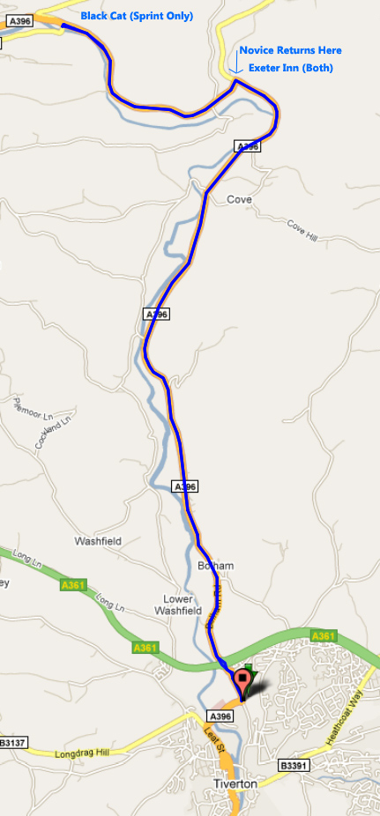


At mount box take third exit from roundabout. Ride along Bolham Road. Beware of pedestrian crossing.

Take first exit at the roundabout. Take second exit at next roundabout (North Devon Link Road). Beware here this is a very fast and busy roundabout.
Follow signs straight along the A396 to Exeter Inn.

Novice competitors will go right around the roundabout and return to the leisure centre the way they came.

Sprint competitors will take first exit at Exeter Inn roundabout and continue to Black Cat. You will have to make a u-turn here and will be told to put one foot on the ground before beginning the return journey. Ride back to the leisure centre along the same route.

Take particular care on the North Devon Link road roundabout and on the next roundabout. Remember normal traffic rules apply here i.e. give way to traffic coming from the right.

The entrance to transition is sharp left. Dismount in marked box.

Rack your bike in the same place you took it from.

The Bike Route Profile
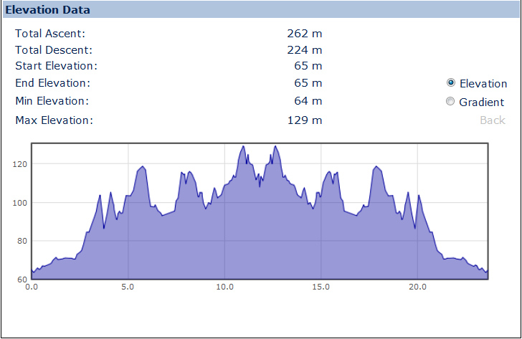

Do not remove your helmet until your bike is safely racked.

Competitors should be aware of other runners and cyclists in transition. Please note only competitors and race officials/marshals are allowed in the transition area before and during the race.

Out of transition you should run along the path behind the leisure centre. Please be careful on the wooden steps at the end of the path. Then run past the front of the leisure centre to the corner and turn right along the footpath. Beware of cyclists approaching from the opposite direction towards the mount point.
Run
Bike-Run Transition
Run to the next corner and turn right up the hill. As the hill levels out marshals will direct you along a pedestrian path. Run along this path keeping left and looking out for pedestrians and other runners coming the other way.

You will be directed by a marshal near the end of this path to turn around. You then head back the way you came. Novices return to the leisure centre, Sprinters turn left up the hill to Peoples Park.

At the park, run past the first gate, keeping to the pavement,(with the park railings on your right), until you reach the gate at the far end of the park. There a marshal will direct you to run through the gate and along the top path back towards the first entrance gate. Pass through this gate and run back the way you came, down the hill towards the Leisure Centre.

As you reach the footbridge over Bolham Road, you turn sharply left through the gate to the Skate Park and onto the astro turf where you enter the finish chute.

All novice competitors will run 3km. All sprint competitors will run 5km

The Run Route

Novice Race (3K)
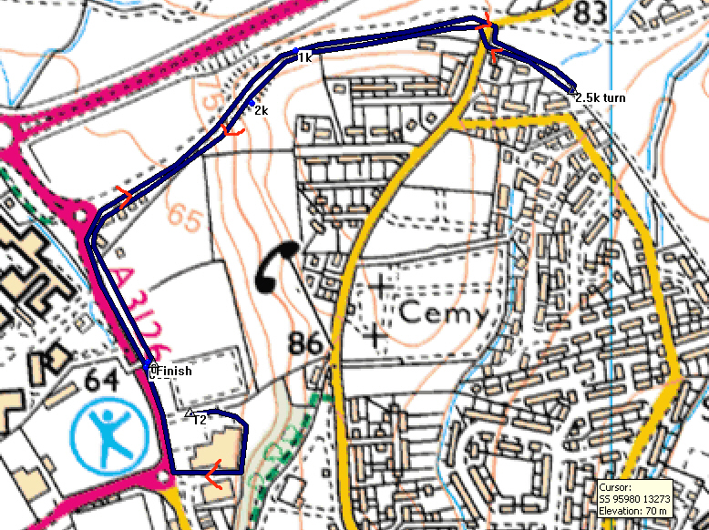

Sprint Race (5k)
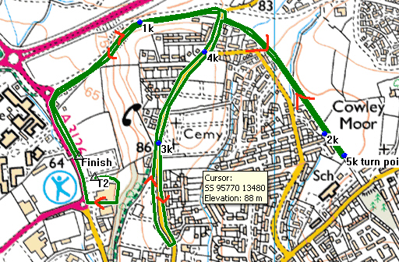

Prizes will be awarded to the top three of each age-group category. If there are four or five in a category then the top two only will receive prizes; if there are three or fewer then only the winner will receive a prize.

We will be giving out prizes from the registration area at about 3.30pm for the sprint race. The Novice race prize giving will take place after its conclusion at around 10am.
Results
Prize Giving

Results will be posted onto the Exeter Triathlon Club website www.exetertri.co.uk within 24 hours of the event. Provisional results will be available at some point after the event.

